**Capstone Project -The Battle of Neighborhoods**

**By Selvaraj Velayudham**

**Introduction and Business Problem**

**Toronto** is the [provincial](https://en.wikipedia.org/wiki/Provinces_and_territories_of_Canada) [capital](https://en.wikipedia.org/wiki/Capital_city) of [Ontario](https://en.wikipedia.org/wiki/Ontario) and the [most populous city in Canada](https://en.wikipedia.org/wiki/List_of_the_100_largest_municipalities_in_Canada_by_population), with a population of 2,731,571 as of 2016. Current to 2016, the Toronto [census metropolitan area](https://en.wikipedia.org/wiki/Census_metropolitan_area) (CMA), of which the majority is within the [Greater Toronto Area](https://en.wikipedia.org/wiki/Greater_Toronto_Area) (GTA), held a population of 5,928,040, making it Canada's [most populous CMA](https://en.wikipedia.org/wiki/List_of_census_metropolitan_areas_and_agglomerations_in_Canada). The city is the anchor of the [Golden Horseshoe](https://en.wikipedia.org/wiki/Golden_Horseshoe), an urban agglomeration of 9,245,438 people (as of 2016) surrounding the western end of [Lake Ontario](https://en.wikipedia.org/wiki/Lake_Ontario).[[13]](https://en.wikipedia.org/wiki/Toronto#cite_note-14) Toronto is an international center of business, finance, arts, and culture, and is recognized as one of the most [multicultural](https://en.wikipedia.org/wiki/Multicultural) and [cosmopolitan](https://en.wikipedia.org/wiki/Cosmopolitanism) cities in the world.

The diverse population of Toronto reflects its current and historical role as an important destination for [immigrants to Canada](https://en.wikipedia.org/wiki/Immigration_to_Canada). More than 50 percent of residents belong to a [visible minority](https://en.wikipedia.org/wiki/Visible_minority) population group, and over 200 distinct [ethnic origins](https://en.wikipedia.org/wiki/Ethnic_origin) are represented among its inhabitants. While the majority of Torontonians speak [English](https://en.wikipedia.org/wiki/English_language) as their primary language, over 160 languages are spoken in the city

According to the 2016 Census, [the racial composition of Toronto was:](https://www12.statcan.gc.ca/census-recensement/2016/dp-pd/prof/details/page.cfm?Lang=E&Geo1=CMACA&Code1=535&Geo2=PR&Code2=35&Data=Count&SearchText=Caledon%20East&SearchType=Begins&SearchPR=01&B1=All) White: 50.2% East [India](http://worldpopulationreview.com/countries/india-population/)n: 12.7% (10.8% Chinese, 1.4% Korean, 0.5% Japanese) South Asian: 12.3% Black: 8.5% Southeast Asian: 7.0% (5.1% Filipino) Latin American: 2.8% West Asian: 2.0% Arab: 1.1% Aboriginal: 0.7% (0.5% First Nations, 0.2% Metis) Two or more races: 1.5% Other race: 1.3%

With it's diverse culture , comes diverse food items. There are many restaurants in Toronto, each belonging to different categories like Chinese , Indian , French , Italian etc.

On Jan. 1, 1998, **Toronto's** amalgamation took effect, merging the six previous municipalities that made up Metro **Toronto** – Etobicoke, Scarborough, York, East York, North York, and the City of **Toronto**, into a new singular City of **Toronto**.

So as part of this project , we will list and visualize all major parts of Toronto that has great Indian restaurants.

**Source of Data**

**Data**

For this project we need the following data :

* Toronto data that contains list Boroughs, Neighborhoods along with their latitude and longitude.
  + Data source : <https://en.wikipedia.org/wiki/List_of_postal_codes_of_Canada:_M>
  + Description : This data set contains the required information. And we will use this data set to explore various neighborhoods of Toronto
  + Use Beautiful soup to Scrap library
* Indian restaurants in each neighborhood of Toronto
  + Data source : Fousquare API
  + Description : By using this api we will get all the venues in each neighborhood. We can filter these venues to get only indian Restaurants.
* GeoSpace data- 'https://cocl.us/Geospatial_data'
  + Description : By using this geo space data we will get the Toronto Borough boundaries that will help us visualize choropleth map.

**Approach**

* + Collect the Toronto data from <https://en.wikipedia.org/wiki/List_of_postal_codes_of_Canada:_M> and 'https://cocl.us/Geospatial_data' for Lattitude and Longitude
* Using FourSquare API we will find all venues for each neighborhood.
* Filter out all venues that are Indian Restaurants.
* Find rating , tips and like count for each Indian Restaurants using FourSquare API.
* Using rating for each restaurant , we will sort that data.
* Visualize the Ranking of neighborhoods using folium library(python)

**Conclusion Based on Dataset( Neighbourhood rating Likes , rated & Tips)**

* What is **best location in Toronto for Indian Cuisine** ?
* Which **areas have potential Indian Resturant Market** ?
* Which **all areas lack Indian Restaurants** ?

**Analysis**

We will import the required libraries for python.

* pandas and numpy for handling data.
* request module for using FourSquare API.
* geopy to get co-ordinates of Toronto
* folium to visualize the results on a map

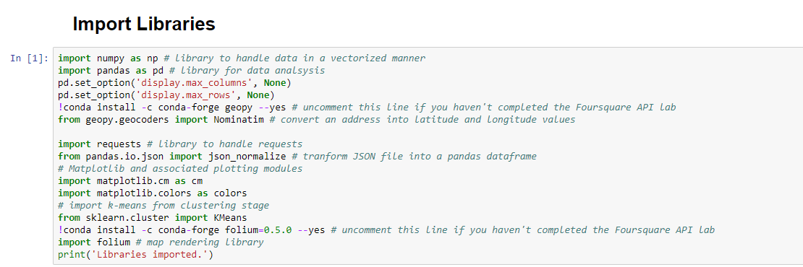

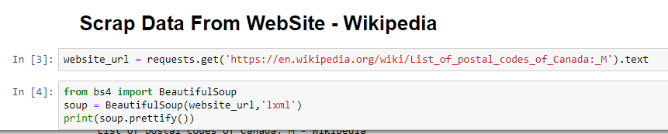

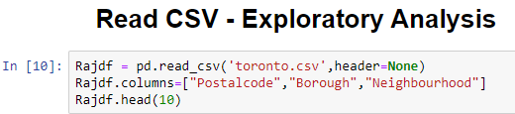

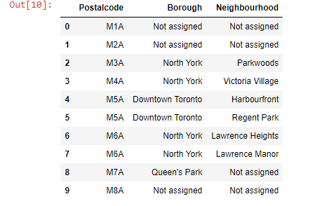

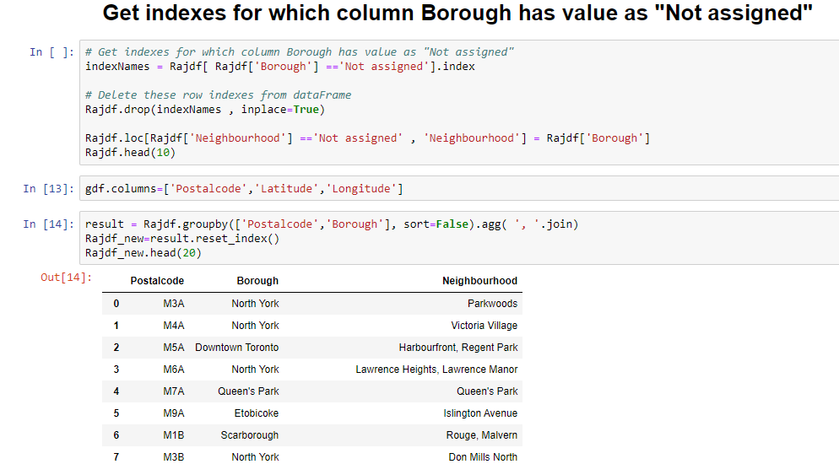

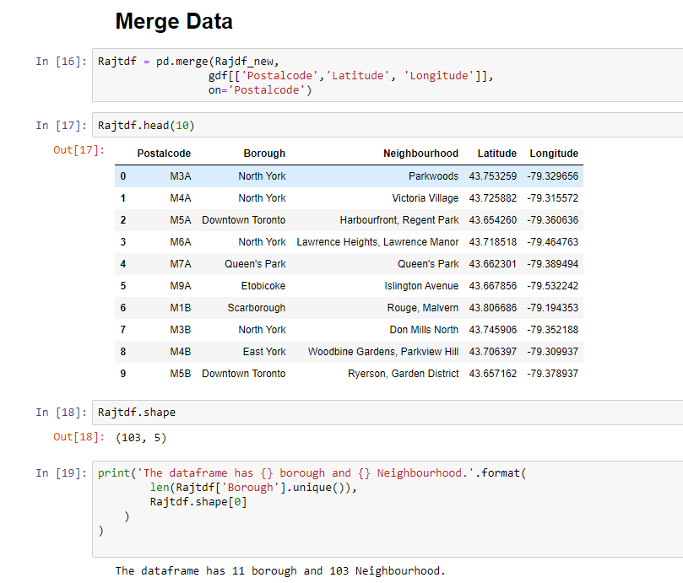

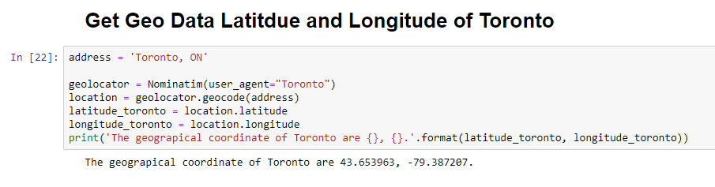



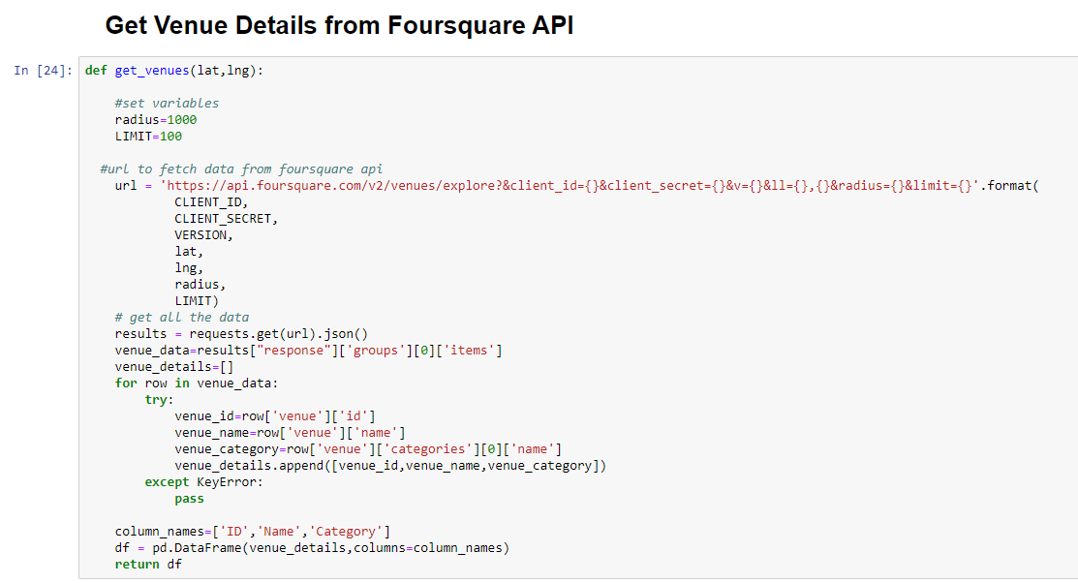

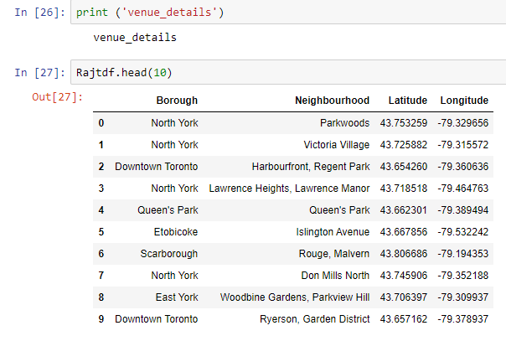

**Methodology**

**Use Chart Visualization Method to Visualize data**

**Plot Bar Chart Number of Neighborhood for each borough in Toronto**

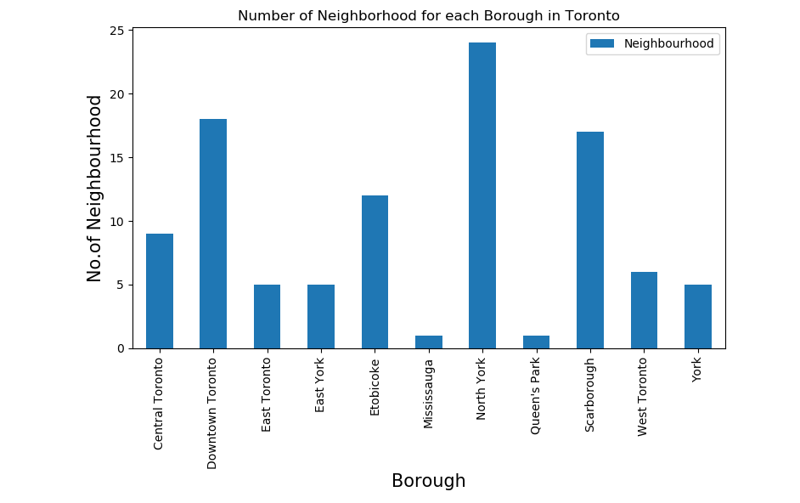

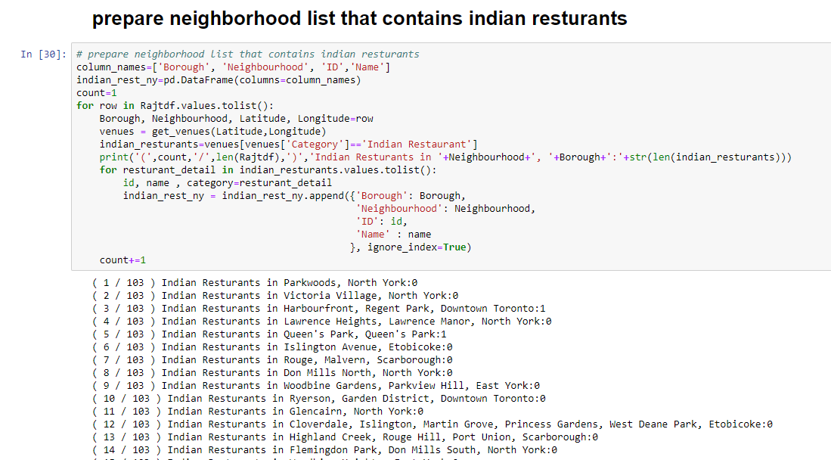

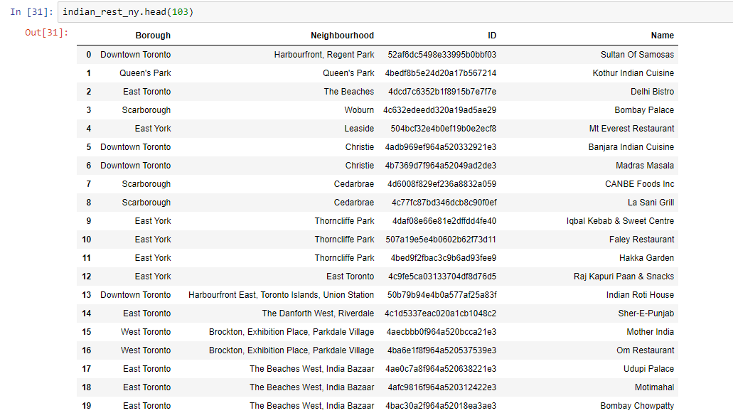

**Plot Bar Chart to show No of Indian Restaurant for Each Borough in Toronto**

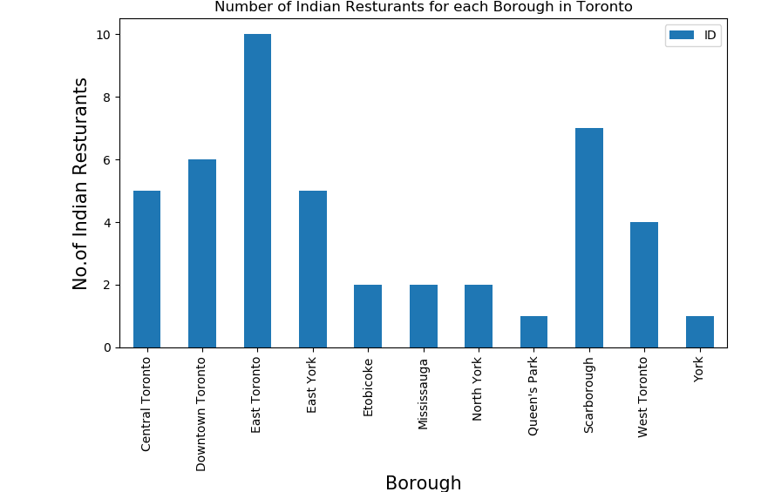

**Plot Bar Chart to show No Indian Restaurant for Each Neighborhood in Toronto**

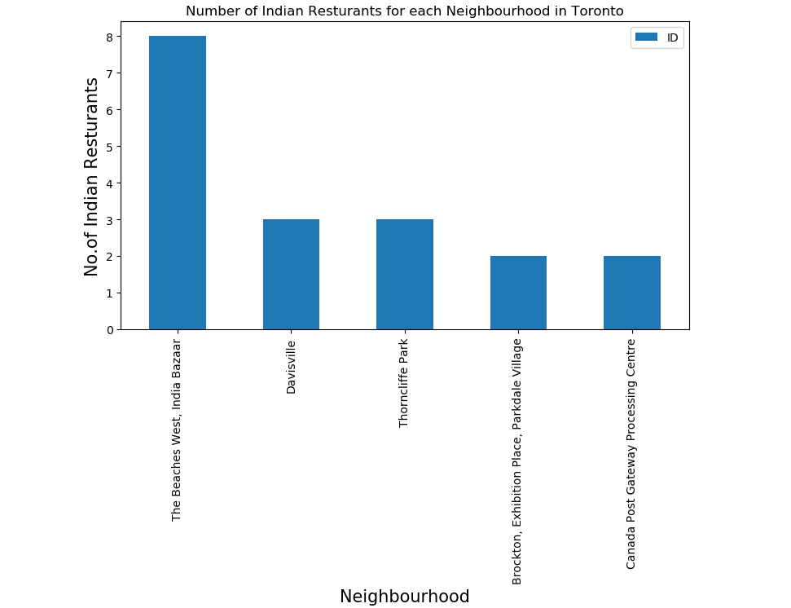

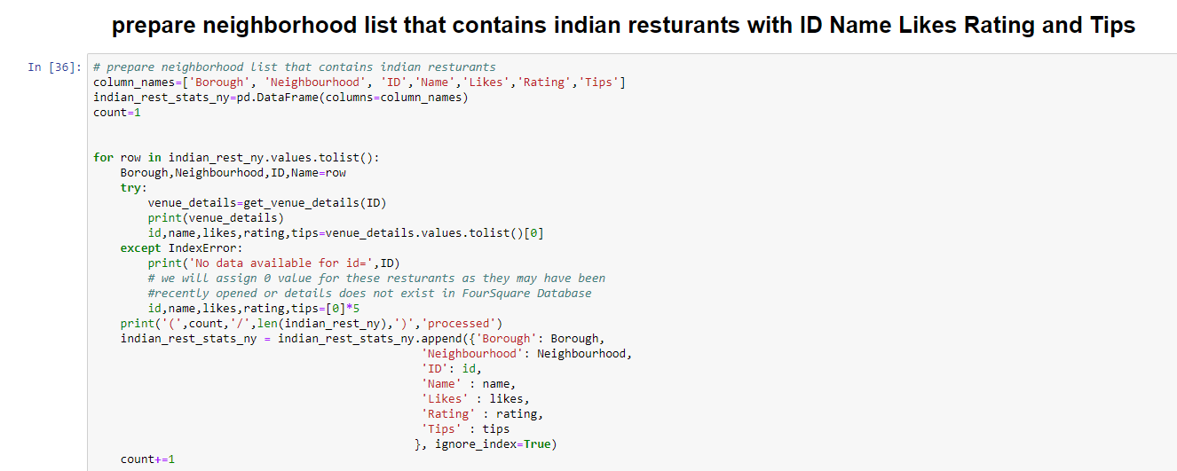

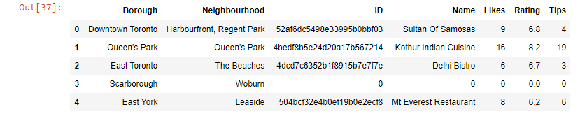

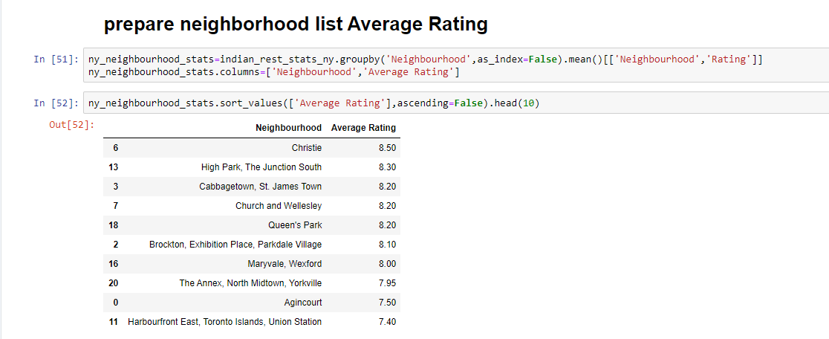

**Results and Discussion Based on Average rating**

**Use Chart Visualization Method to Visualize data**

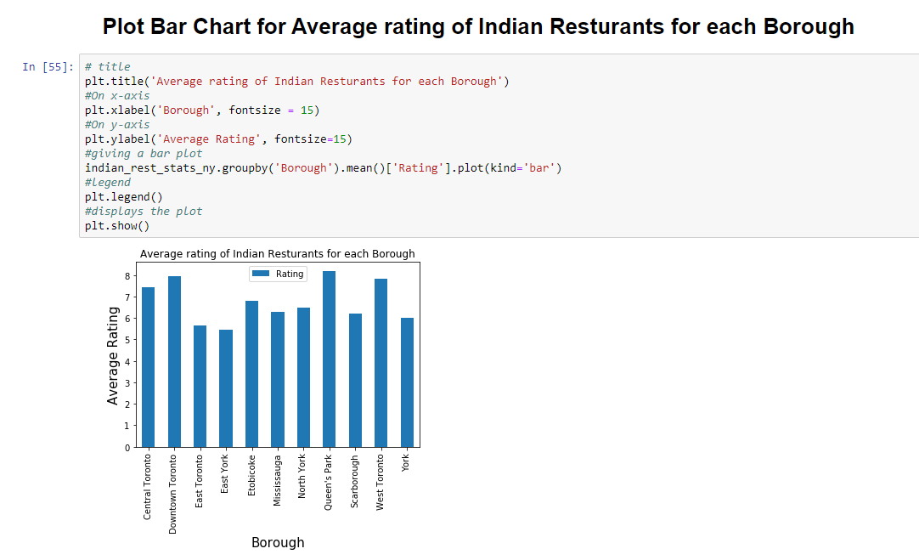

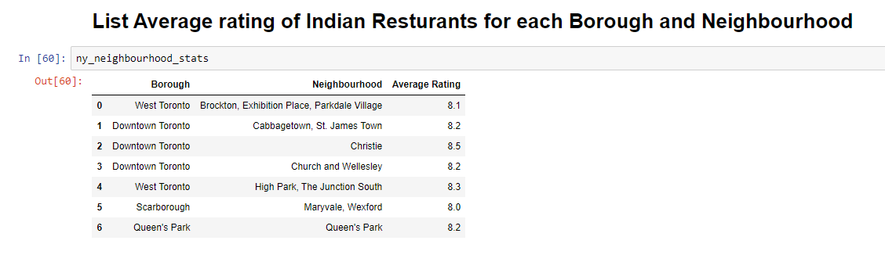

**Get Toronto City Map using Folium**

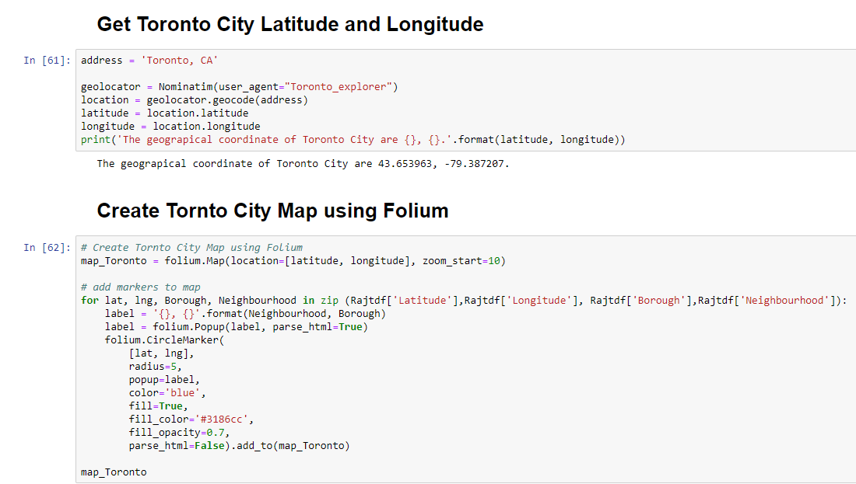



**Conclusion – Based on Above Data**

Downtown Toronto(Christie), Downtown Toronto Cabbage town,

St. James Town ) are some of the best neighborhoods for Indian cuisine.

Queen's Park have potential Indian Restaurant Market

Etobicoke ranks last in average rating of Indian Restaurants.